Google cloud platform project

Apache Web Server on Google Cloud

**By Alshaimaa Alamer.**

Guidelines:  
● First make your own GCP account.  
● second after you make your account enable compute engine ● third create your first virtual machine

Hands-on-deck $:~

VM settings:  
here you make your first VM.

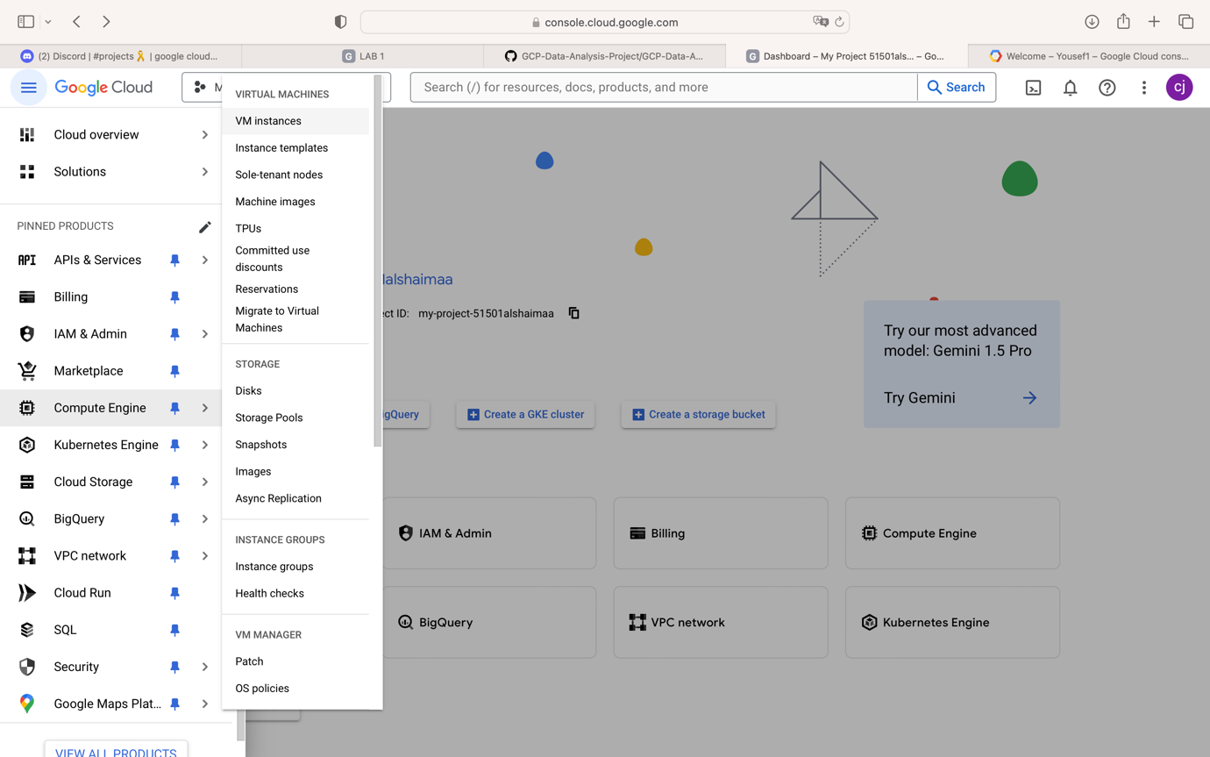

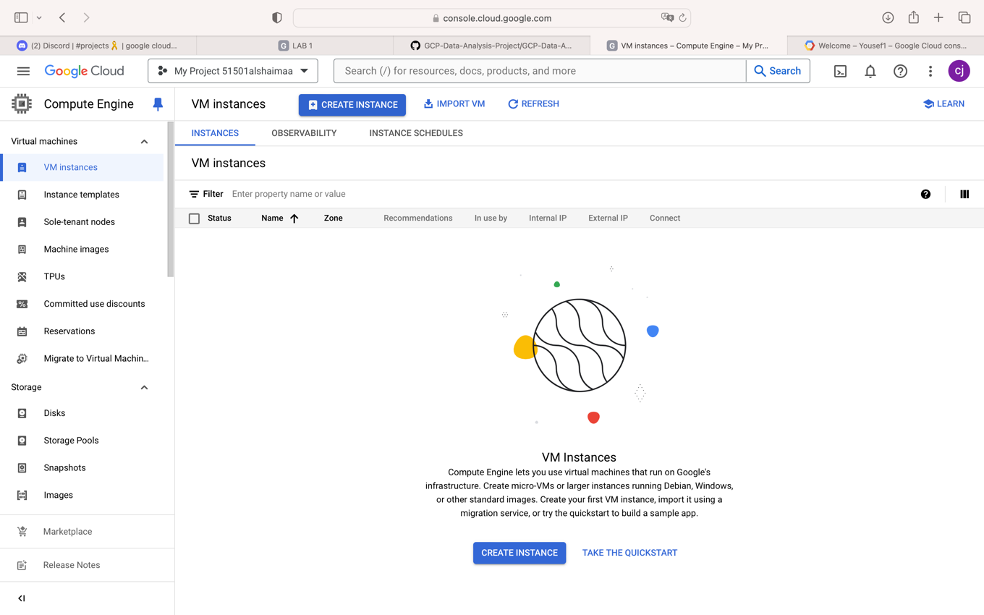

The boot disk settings and the firewall (Allow HTTP and HTTPS traffic) the hit create.

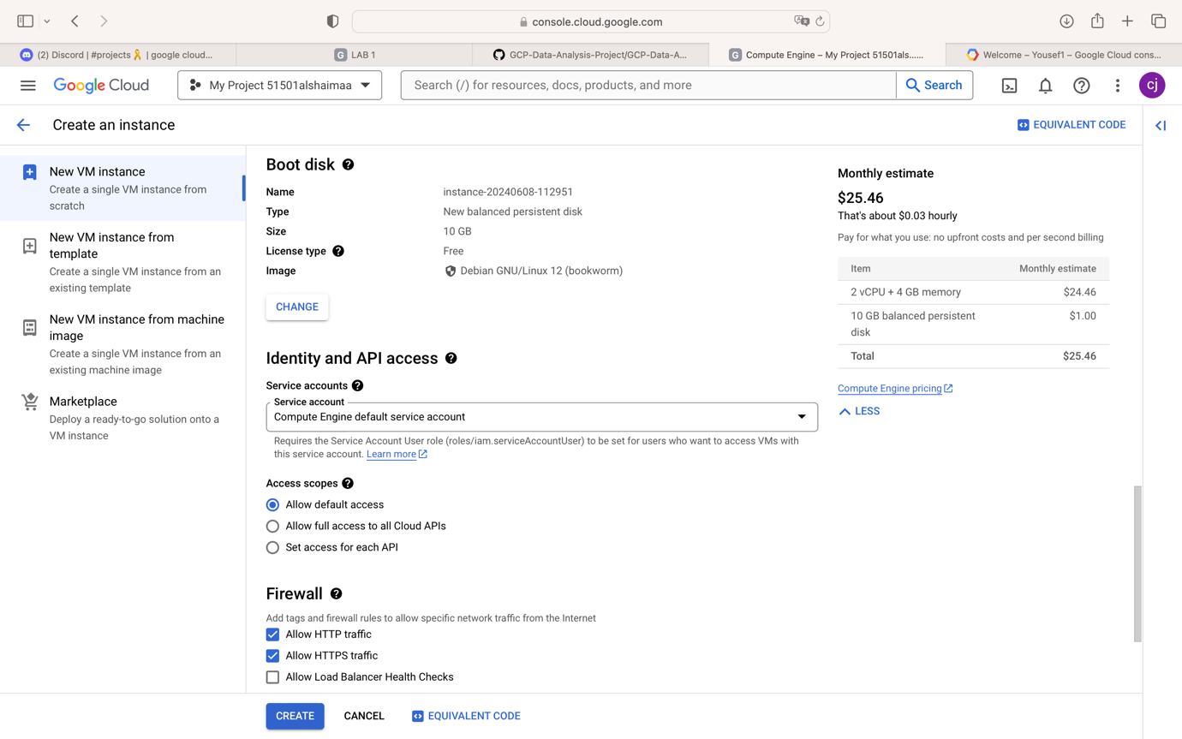

VM SSH:

After we create our first VM, we’ll run SSH from

clicking the SSH button.

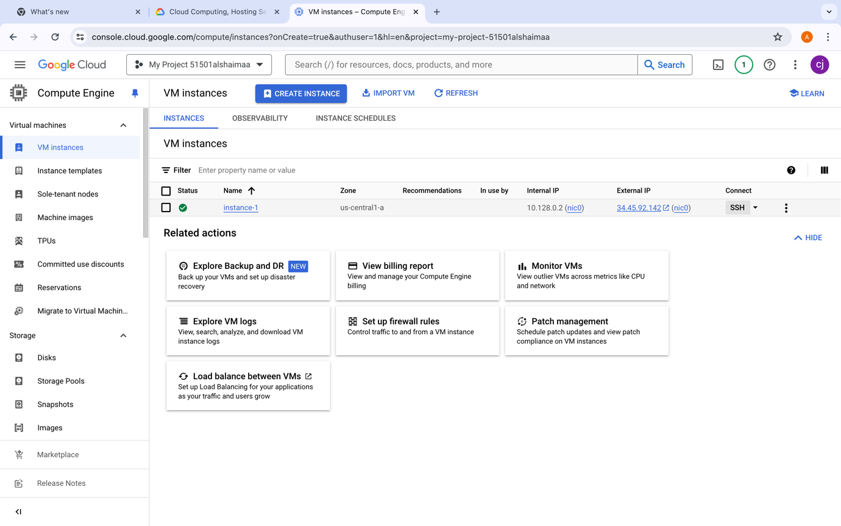



Now we open the SSH window.

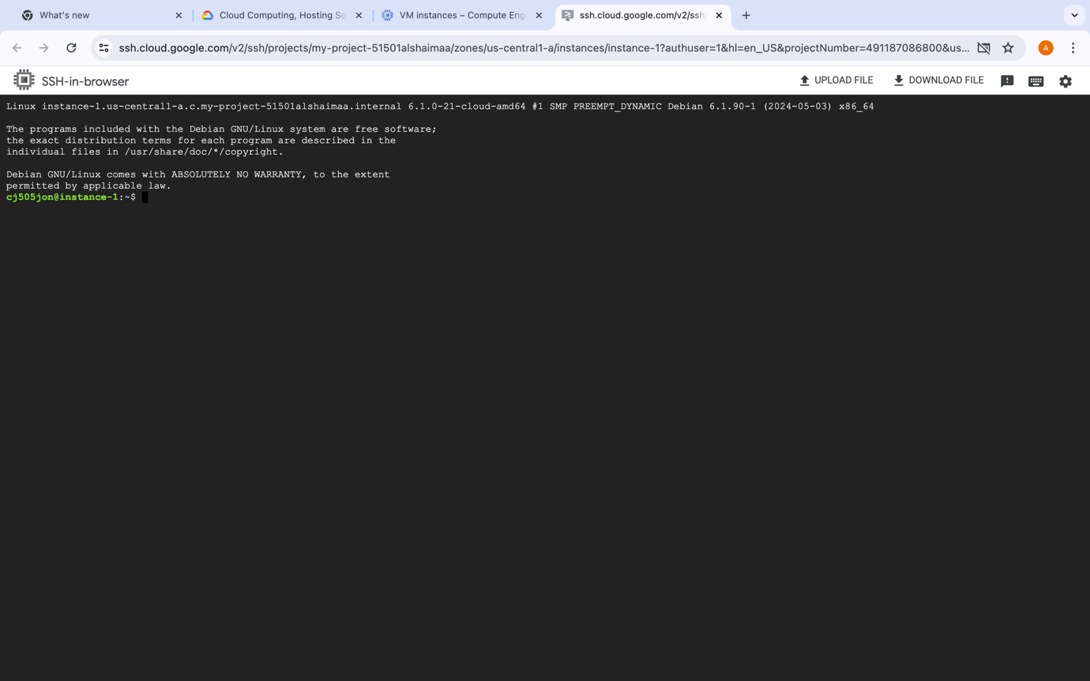

First thing is to update packages by the cmd: apt-get update

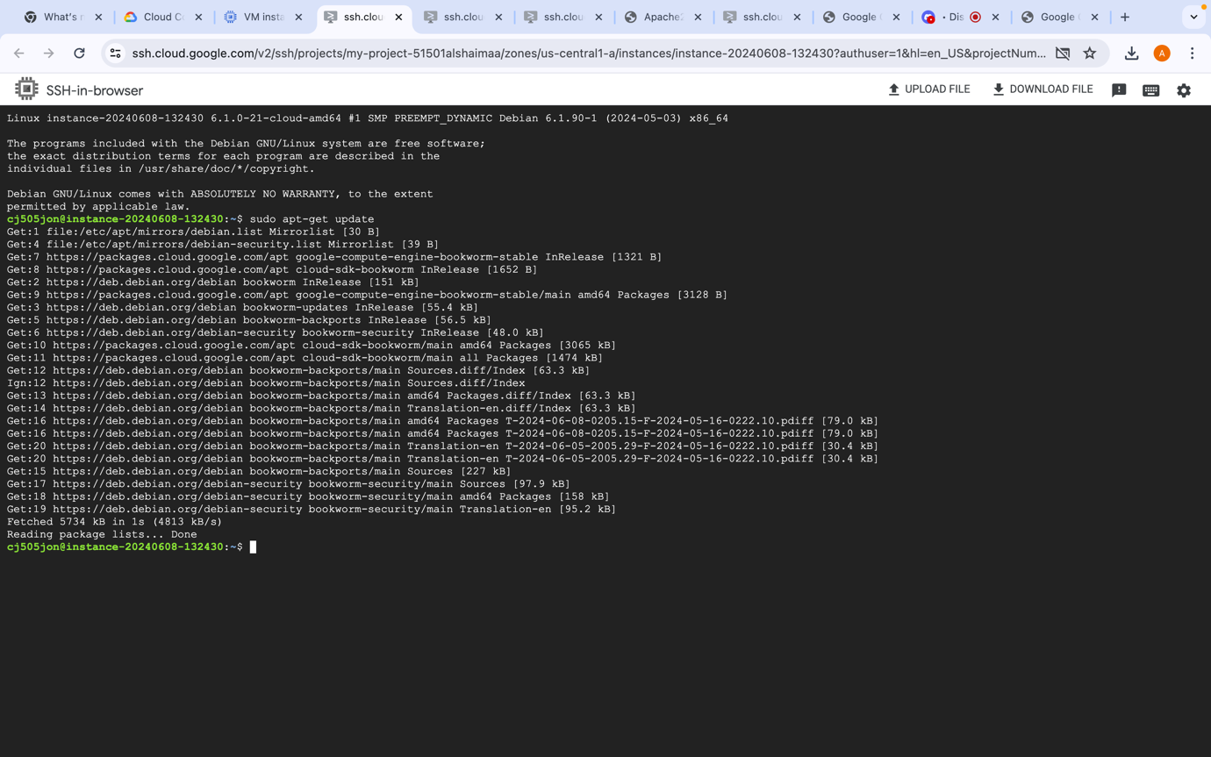

After that install apache2 server the cmd: apt-get install

apache2 -y

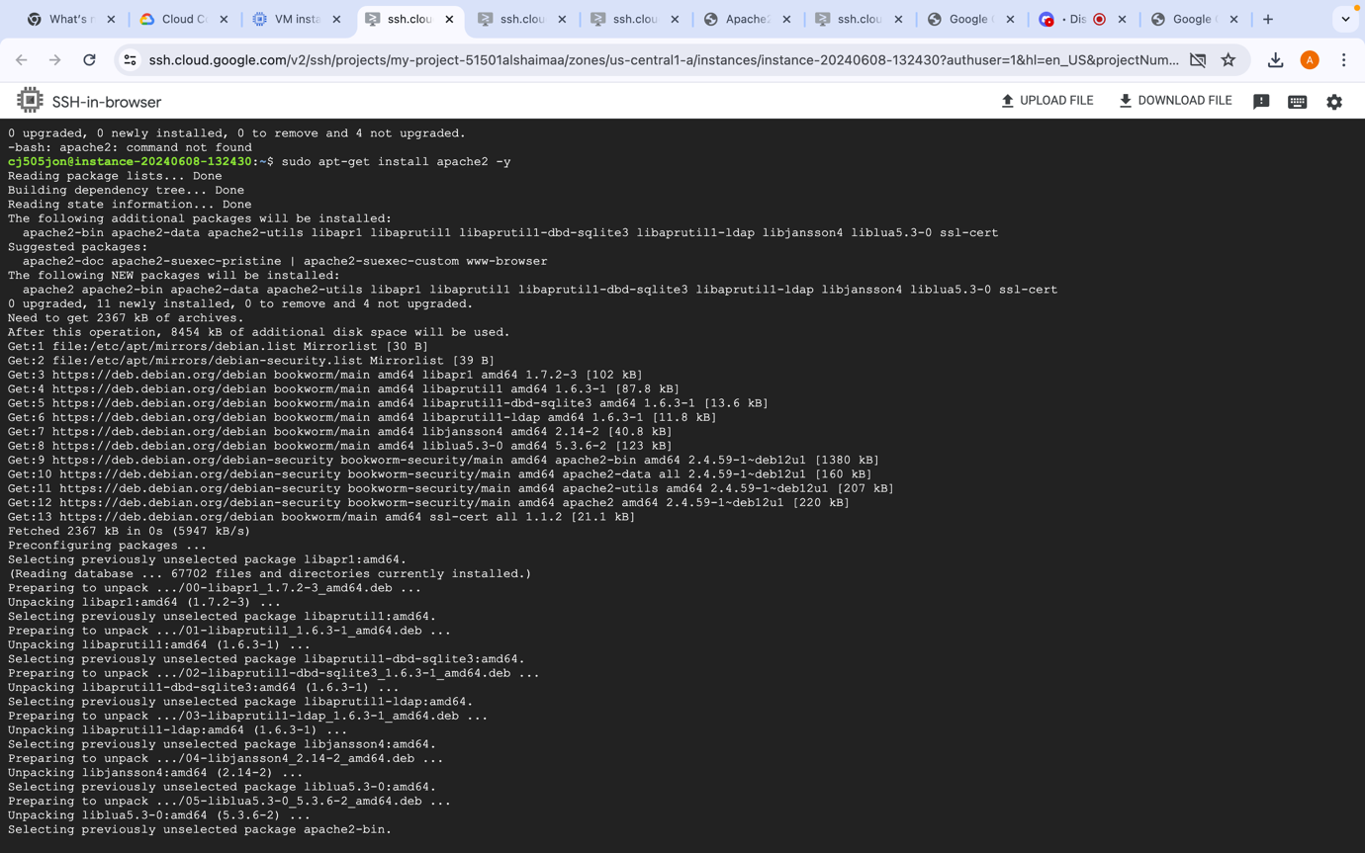

we install apache2 server successfully but how to check if the

server is working the cmd: service –status-all

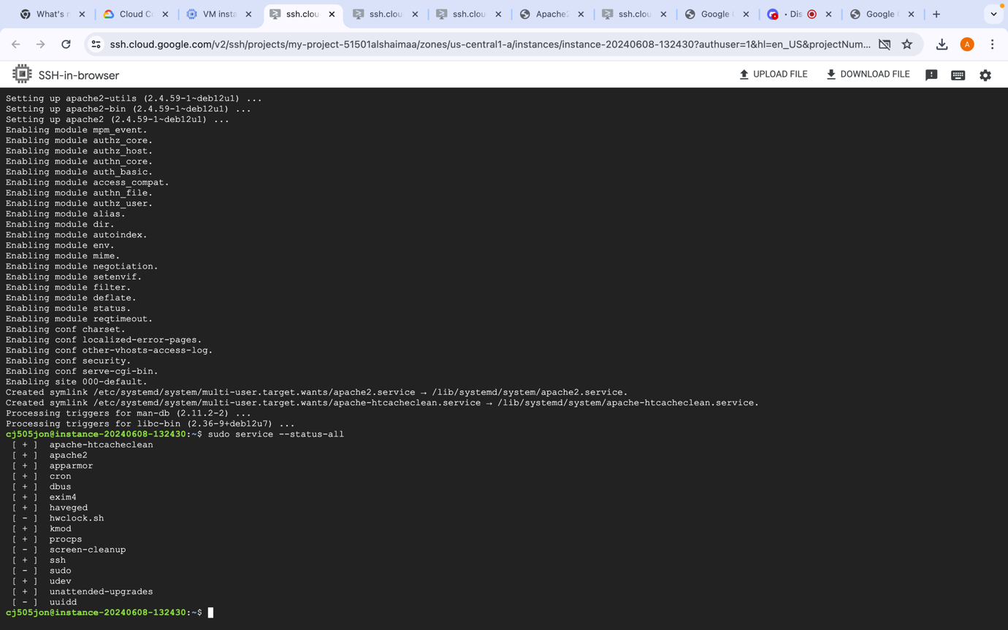

Go to External IP and click on it.

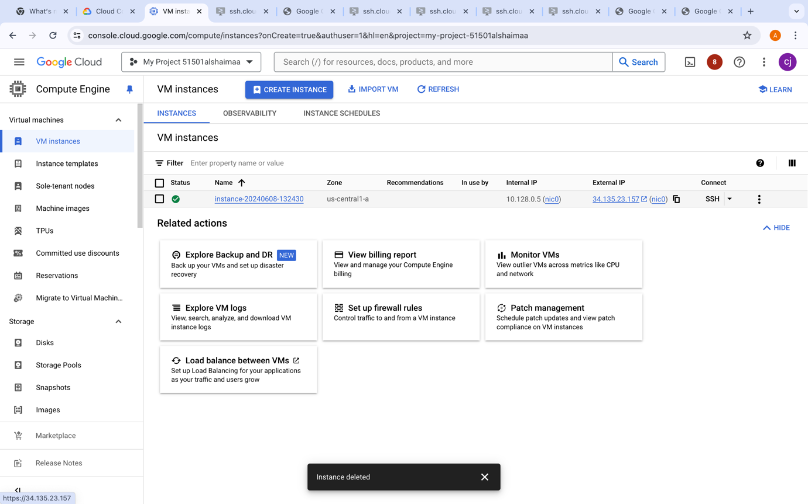



Clicking on External IP will lead us to this page

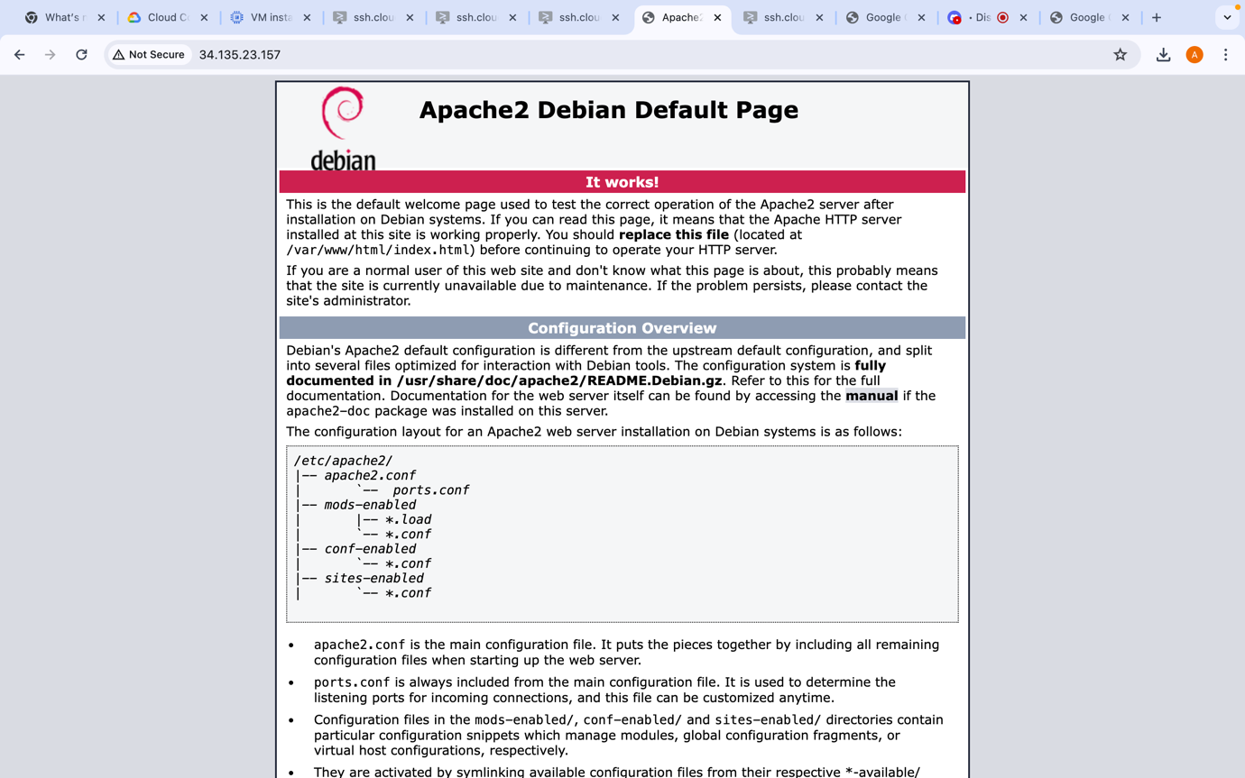

We upload the index.html and move it to /var/www/html

